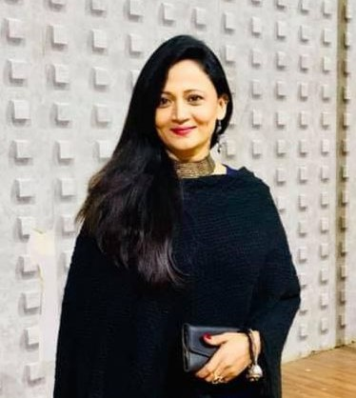

**Smieetaa Madhukar**

**Event & Hotel Management Consultant**

**DESCRIPTION :**

Passionate and versatile actress with a flair for bringing characters to life on stage and screen.

Dedicated hotelier with a commitment to excellence in hospitality management. Skilled in team leadership, operations management & financial acumen.

**RECENT WORK :**

* **My Innovative cooking**

At Maitree snacks & pure veg, we believe in pushing the boundaries of culinary creativity to deliver an extraordinary dining experience. Meet my innovative cooking, Smieetaa Madhukar, whose passion for culinary innovation and dedication to culinary excellence have earned acclaim from food enthusiasts and critics alike.

* **Worked in Theatres, Movies, Series, Short Films and Album Songs - Hindi, Marathi**

**PERSONAL DETAILS :**

**Education:** B.A.

**Mobile :** 7875485597

**E-mail :**

[smieetaamadhukar@gmail.com](mailto:smieetaamadhukar@gmail.com)

**Address :**

Sadashiv Peth, Pune

Maharashtra

**SKILLS & ACTIVITIES :**

* So many crown 👑 winner in fashion shows.
* Social Worker.
* **President** of Human Rights for Protection - **Pune Dist.**
* Maitree snacks & pure veg - **Owner**

**Movies and Series**

* Marathi Movie
* Marathi Web Series
* Marathi Album Songs
* Hindi Album Songs

**Theatre**

* Nawra Vikne Ahe
* Sonography
* Premacha Antarparh
* Pagla Ghoda
* Gharoghari Hich Bombabomb

**OTHER RECENT WORKS :**

**Also worked in Short Films - Hindi and Marathi**

**EXPERIENCE :**

Experienced hotel management professional with a proven track record of success in overseeing the operations of upscale hospitality establishments. With multiple years of hands-on experience in the industry:

* expertise in all facets of hotel management, including front desk operations, housekeeping, food and beverage service, and guest relations.
* Known for my strategic leadership, attention to detail, and commitment to delivering unparalleled guest experiences,
* I excel in optimizing operational efficiency, driving revenue growth, and maintaining the highest standards of quality and service.
* Passionate about hospitality and dedicated to exceeding guest expectations, I am poised to contribute to the success and reputation of your esteemed establishment.

**About My Cooking**

With a background steeped in culinary arts and a flair for experimentation, my cooking brings a fresh perspective to traditional flavors and techniques. Drawing inspiration from global culinary trends, seasonal ingredients, and modern gastronomy, my cooking crafts imaginative dishes that tantalize the palate and delight the senses.

**Innovative Culinary Philosophy**